Project Design Documentation Template:
Last updated: July 29th, 2026

1. Project Title & Version Control
Give your project a clear, relevant name that communicates what you are building. Include a working version so the document can be updated as the project develops.
Version Control
Version: Mapping
Date: 08/03/2026
Change Log: The Mapping of the project is beginning.

2. Project Summary (2-3 sentences)
This Project is the Far Lands Website vol.2 Due to the first prototype website being rushed I will now upgrade the older website into a more flexible website with better features and social grounds.

3. Problem Statement / Use Case
This website is a content updating website under my platform for early content, ideas, and better ways to explore gaming within a single website all together.

4. Goals and Objectives
My main goal is to set up a forum page for listed content and a comment section as well as a Login system or Sign in system so users have their own profile and free will, Financial system will be added with the category {Donations} or VIP pass that’s in a cheap price for exchange of early content, and customization Benefits.

5. Key Features / Functions
Reporting System so there are no out of line discussions or comments to ensure everyone's safety and happiness, I’m mainly excited for the Fan Letter System so users can reach out to me directly for advice, deep discussions, and even suggestions or serious issues if they don't use {Feedback}

6. Tech Stack and Tools
This project will primarily use Python with the Django framework to develop the backend because it provides built-in security features such as authentication, authorization, CSRF protection, and SQL injection prevention. The frontend will be developed using HTML and CSS to create responsive and user-friendly interfaces, while JavaScript will be used to add interactivity where needed. SQLite will be used during development, with PostgreSQL as a scalable database option for deployment, and the OpenAI API will be integrated to power the AI assistant feature for user support and content assistance.

7. Architecture / Workflow Diagram
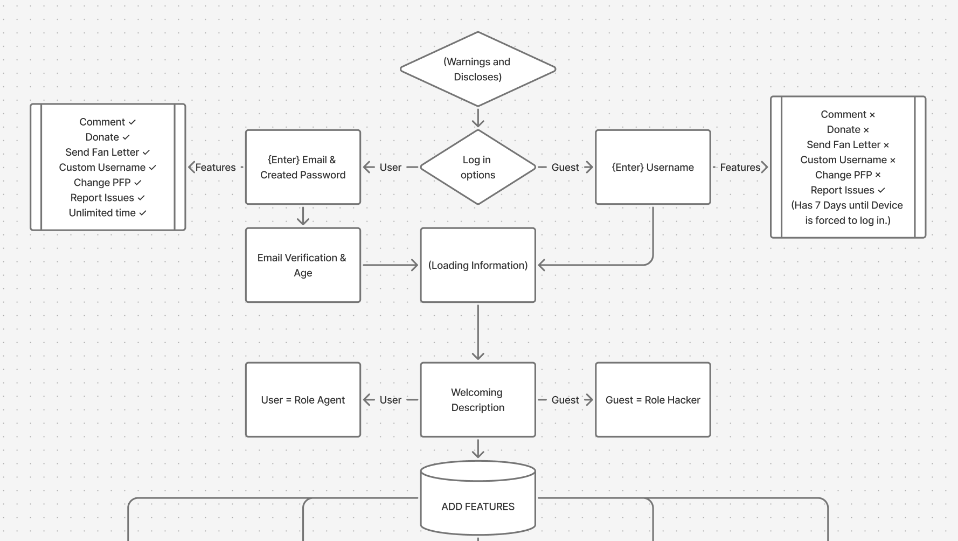

8. Timeline / Weekly Milestones
Use this section to plan how your project will move through the software development life cycle (SDLC) over 12 weeks. Adjust the specific tasks to fit your project, while keeping the overall progression from planning through release.
Week | Project Outcome | SDLC Stage and What It Means
Week 1 | The project will be undergoing an ordered list of features and updates. | Mapping and planning each step, features, and upgrades into the website neatly and in an orderly fashion.
Week 2 | Project requirements, scope, constraints, and essential MVP features are documented. | Requirements Analysis: Define what the project must do and what is outside the current scope.
Week 3 | Success criteria, user stories or use cases, and a prioritized project backlog are completed. | Requirements and Project Planning: Turn the project idea into clear, testable work.
Week 4 | Architecture, workflow, data needs, interface ideas, and technology choices are designed. | System Design: Decide how the parts of the solution will work together before full development begins.
Week 5 | Development environment, repository, project structure, and an initial prototype or foundation are established. | Implementation Setup: Prepare the tools and build the first working structure of the project.
Week 6 | The first group of core MVP features is built and reviewed against the requirements. | Implementation: Develop the essential functions in small, testable pieces.
Week 7 | Remaining core features are built and connected into one working solution. | Implementation and Integration: Combine components and confirm that they work together.
Week 8 | Core functions are tested; defects, missing requirements, and integration issues are documented. | Testing and Quality Assurance: Check whether each part behaves as intended and identify problems early.
Week 9 | User, system, security, accessibility, or performance testing is completed as appropriate, and priority issues are fixed. | Validation and Refinement: Confirm that the solution works for its intended user and use case.
Week 10 | The project is stabilized, code and content are cleaned up, and technical and user documentation are completed. | Release Preparation: Improve reliability, usability, and clarity before publishing.
Week 11 | The project is deployed or published in its final environment, and the demonstration or presentation is prepared. | Deployment: Make the completed solution available and confirm it works outside the development environment.
Week 12 | Final acceptance testing, project demonstration, documentation review, reflection, and future recommendations are completed. | Release and Maintenance Planning: Verify completion, communicate the result, and identify what should happen next.

9. Risks and Risk Mitigation
Risks of this website is if something wrong goes on with the socialism comments or discussions and such that bypasses the blacklisted word system and goes unreported then the negative content that users post can be overlooked and be exposed to the public, making the website unsafe and corrupted by sneaky activity.

10. Evaluation Criteria
Testing every feature and every possibility that is possible to come up with negative or positive to ensure the safety and the enjoyment of all users.

11. Future Considerations
A guild system for users to create a party to chat with or call to whenever they want to play the physical game but want to access the website features before starting, or maybe looking for a party maybe even new friends to play with in a match-up.

